COMPANY PROFILE

DRESCHER CONSULT LTD (DCL)

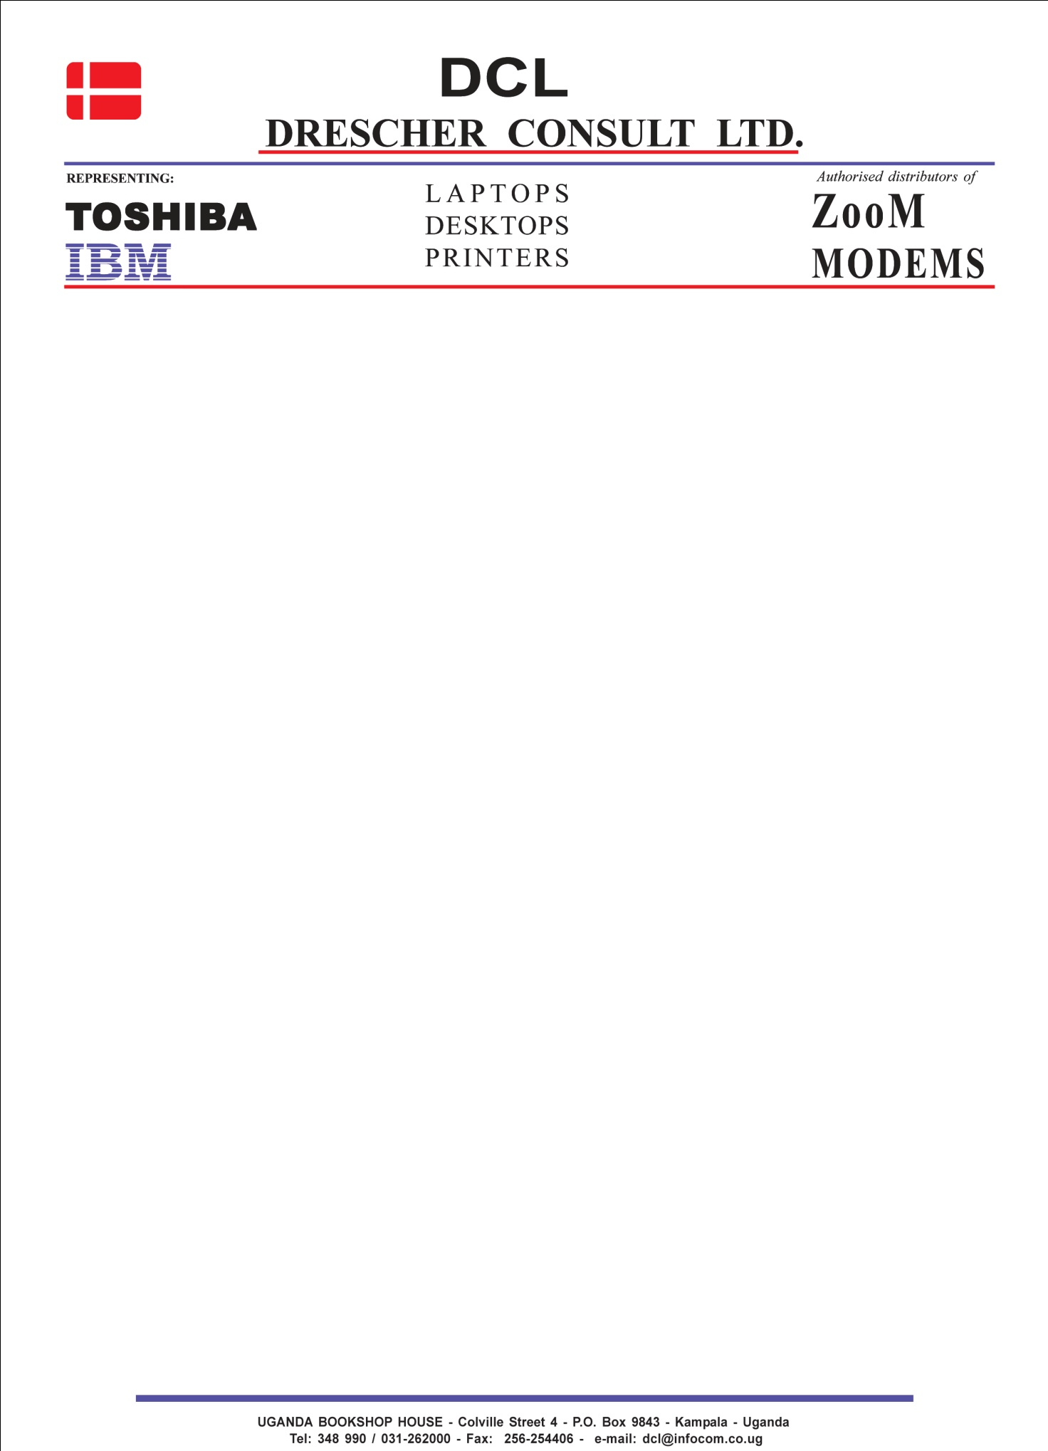

TABLE OF CONTENTS

1. ABOUT US

1.1 BACKGROUND

1.2 MISSION

1.3 COMMITMENT TO SERVICE

1.4 EXPERIENCE AND CORE COMPETENCIES

1.5 OUR STRUCTURE

2. OUR BUSINESS

2.1 PRODUCTS

2.2 SERVICES

3. OUR CUSTOMERS

4. RELEVANT CONTRACTS UNDERTAKEN

5. LEGAL DOCUMENTS

**UGANDA BOOKSHOP HOUSE – Colville Street 4 - P.O.Box 9843 –Kampala – Uganda**

**Tel: 0414- 348 990 / 0312-262000 – Email: dcl@entebbe.eu**



1. **About us**
   1. **Background**

Drescher Consult Ltd is one of the leading providers of ICT products and services in Uganda. The Company has been and is continuously transforming itself to meet the challenges of the ever changing business environment of our customers.

Drescher Consult Ltd has been involved in the provision of IT solutions for the last 15 years.

Our market and customers comprise of Government, NGOs, Public and private companies, Schools, Hospitals, Financial service organizations and individual consumers. Our solutions are tailored to meet the requirements of our clients in all cases.

We are involved in hardware such as Laptops, servers, desktops, printers, scanners, ups, peripherals accessories, Networking Equipment, software applications, and services. We are continuously developing skills to ensure that our services are of the highest standards. Quality is our objective in all respects of the business.

**UGANDA BOOKSHOP HOUSE – Colville Street 4 - P.O.Box 9843 –Kampala – Uganda**

**Tel: 0414- 348 990 / 0312-262000 – Email: dcl@entebbe.eu**



* 1. **Our Vision**

To be at the forefront of the market with special attention to complete customer satisfaction, by reducing downtime to a minimum, and by supplying our customers with the right equipment for their everyday use.

Drescher Consult Ltd is committed to the delivery of quality in all respects of its business. Information technology based solutions is our business and we ensure we deliver to meet our customers’ expectations.

We continuously strive to achieve significant and profitable market share while remaining a responsible company. All this is achieved by;

* Ensuring we are recognized by our customers as their strategic IT partner, supplying technically superior and innovative, high quality services and products.
* Ensuring we are recognized by our customers as responsive, Ethical, and oriented towards their needs.
* Ensuring we are recognized by our employees and business community for excellent and integrity in managing the company’s business.
* Providing all system solutions on time and wit in budget and meeting the customers’ requirements by using accepted quality control processes.
* Recruiting the best skilled ma power and providing an environment of achieving personal excellence and growth for all our team members.

**UGANDA BOOKSHOP HOUSE – Colville Street 4 - P.O.Box 9843 –Kampala – Uganda**

**Tel: 0414- 348 990 / 0312-262000 – Email: dcl@entebbe.eu**



* 1. **Commitment to Service**

Drescher Consult Ltd is committed to offering total service to its customers in order to achieve and exceed their business and technology requirements and expectations. Our customers can be confident that, in engaging our services, they will be working with a strategic IT Partner, striving towards achieving common goals and objectives. As already indicated, we constantly strive to improve and increase the range of our products/services, by keeping abreast of technology trends and improving our status with our partners.

**UGANDA BOOKSHOP HOUSE – Colville Street 4 - P.O.Box 9843 –Kampala – Uganda**

**Tel: 0414- 348 990 / 0312-262000 – Email: dcl@entebbe.eu**



* 1. **Experience and Core Competencies**

Drescher Consult Ltd has skilled staff to undertake large projects successfully. Where the clients’ need dictate, we augment our resources with specific skills from our sister companies, as well as from our strategic business partners. Our involvement in many varied projects has resulted in development of significant competencies in the following:

* Infrastructure solutions
* Desktop and Laptop solutions
* Business Services solutions
* Printing solutions
* Storage solutions
* Messaging Solutions
* Office productivity solutions
* Networking solutions

**IT Services**

* Workshop repairs
* Onsite Recovery and Repairs
* Managed support services
* Systems Integration
* IT system Audits

**Consumables and Parts**

* We have a department that supplies consumables and parts for various products.

**UGANDA BOOKSHOP HOUSE – Colville Street 4 - P.O.Box 9843 –Kampala – Uganda**

**Tel: 0414- 348 990 / 0312-262000 – Email: dcl@entebbe.eu**



1. **Our Business**
   1. **Products**

Drescher Consult Ltd is committed to become a world class ICT solutions provider by using best of breed products and engaging best practices from industry leading technology companies.

We have a broad spectrum of products and services to select from quality and reliability are not just buzzwords at Drescher Consult Ltd, they are the goals our team strives to achieve on a daily basis. Some of the partners that we are engaged with are:

* Toshiba. One of the leading manufacturer of Laptops
* HP: One of the leading companies in the supply of Personal computers, Laptops, Servers, Printers, scanners, Display devices, infrastructure management Software and Services.
* Dell: one of the leading manufacturers of Business PCs , Laptops, Projectors, Servers and Printers.
* IBM: Is a leading IT solutions company and manufacturer of high end RISC and Intel Servers, network management software, office productivity software and providing of consultancy services.
* APC: Manufacturer of power systems such as uninterruptible power supply, voltage regulators, line stabilizers, etc.
* Tripp-Lite: Manufacturers of Tripp-lite UPSs and extension cables
* Cisco: For solutions involving delivery and storage of enterprise data, voice and video over the LAN and WAN.
* D-Link: A cost effective networking solutions for the SME market
* In addition, we also supply accessories and consumables to support the various technologies we supply.

**UGANDA BOOKSHOP HOUSE – Colville Street 4 - P.O.Box 9843 –Kampala – Uganda**

**Tel: 0414- 348 990 / 0312-262000 – Email: dcl@entebbe.eu**



* 1. **Services**

We have a wide range of services which include:

Hardware and Software maintenance support services and IT Audits, Consultancy Services, installation Services, Managed Services and IT Audits.

We provide services in our areas of expertise using best practices that ultimately mean high levels of service provision and reliability.

Our services are aligned with ITIL service management guidelines to ensure consistency on every engagement.

We have a team of IT professionals trained to provide guaranteed service levels for support and maintenance contracts. We have rapid access to expert assistance, coupled with dynamic and adaptable workshop.

**UGANDA BOOKSHOP HOUSE – Colville Street 4 - P.O.Box 9843 –Kampala – Uganda**

**Tel: 0414- 348 990 / 0312-262000 – Email: dcl@entebbe.eu**



1. **Our Customers**

* Ministry of Water and Environment
* Ministry of Local Government
* Ministry of Lands, housing and urban development
* Ministry of Defence
* Ministry of Labour, Gender and urban Development
* Ministry of ICT
* Makerere University
* Uganda Law Reform Commission
* Uganda oil seed producers and processors association
* Uganda Human Rights Commission
* ChildFund International
* Mulago Referral Hospital
* US Department of State
* International HIV AIDS Alliance
* Office of Auditor General
* CARE International in Uganda
* Development Research and Training (DRT)
* NTV Uganda/ Africa Broadcasting (U) Limited
* Hospice Africa Ltd
* IITA
* IUCN

**UGANDA BOOKSHOP HOUSE – Colville Street 4 - P.O.Box 9843 –Kampala – Uganda**

**Tel: 0414- 348 990 / 0312-262000 – Email: dcl@entebbe.eu**



1. **Our structure**

Managing Director

Operations

Sales and Marketing

Office Admin

Stores

**UGANDA BOOKSHOP HOUSE – Colville Street 4 - P.O.Box 9843 –Kampala – Uganda**

**Tel: 0414- 348 990 / 0312-262000 – Email: dcl@entebbe.eu**



**REPUTABLE ORGANISATIONS FOR REFERENCE**

|  |  |
| --- | --- |
| **Name** | **Address** |
| **Makerere University** | **Procurement and Disposal Unit**  **Makerere University**  **P.O Box 7062, Kampala** |
| **Ministry of Water and Environment** | **Procurement & Disposal Unit Building**  **Ministry of Water and Environment**  **P.O Box 20026, Kampala** |
| **Ministry of Lands, Housing and Urban Development** | **The Head Procurement and Disposal Unit**  **Ministry of Lands, Housing and Urban Development**  **P.O Box 7096,**  **Kampala** |
| **Ministry of Local Government** | **Procurement & Disposal**  **Ministry of Local Government**  **Floor 6 Workers House**  **P.O Box 7037, Kampala** |
| **Uganda Law Reform Commission** | **The Head Procurement and Disposal Unit**  **Workers House Floor 8 South Wing**  **Plot 1 Pilkington Rd**  **P.O Box 12149,**  **Kampala Uganda** |